**School of Information Technology**

**Proposal for IT204F Group Project Assignment**

**Module Group: PF2532**

**Members: Kaede-leader (251012U), Jin Hui (251142L), Kimlin (251192S), Venise (251218B), Devangana (251344N),**

**Introduction**

Thrive Cafe found in 1987, is a rising food and beverage business that strongly emphasis on their customer experience and work efficiency. Thrive Cafe specialises in serving good quality drinks and pastries to our customers, and this is where customer service comes in and plays a crucial role in managing customer satisfaction and loyalty to our café. As part of the innovative drive, Thrive Cafe has found the need for a more structured and effective staff training approach.

To support this goal, we have decided to develop a digital staff training application to train both new and existing staff in their customer service standards. To modernise our café’s business operations, we aim to improve our customer service consistency, boost staff confidence when serving customers, and enhance our own café's performance.

**Project Statement**

Thrive Café is having difficulties in providing efficient yet reliable customer service training for both new and part-time staff. Training is mainly carried out casually through either spoken guidance or workplace observation, leading to inconsistent service quality and slower training. New staff often feel unprepared when facing real customers, and there is no proper method to evaluate whether they fully understand the café’s service expectations. Without a structured and standardized training system, it becomes difficult for Thrive Café to maintain excellent service as it grows.

Our project aims to improve the current training issues by developing an interactive customer service training app on Scratch. We decided to provide our full-time and part-time staff that is new to our cafe, with guided lessons, simulated practices, scenario-based activities and quizzes to test their understanding, so that they will be able to learn it through an engaging and standardised manner. By combining everything with a single platform, it will help our cafe improve efficiency for our training, ensure that there is a consistent delivery service, and boost our staff confidence before they begin serving customers.

**Objective & Target Users**

Our target users are new and existing staff members. For new staff, they can use this application to learn about the essentials of basic customer service before starting work at our café, while existing staff can use it as a refresher. This ensures that everyone maintains a consistent customer service standard in Thrive Café.

The objective of the staff training app is to help provide employees with an accessible, efficient, interactive, and fun way to develop their individual customer service skills and their confidence to provide our customers with reliable customer service.

**Business needs**

**Business Need 1: Maintaining Consistent Customer Service Standards**

As Thrive Café is a growing food and beverage business, it faces many challenges in maintaining consistent customer service standards due to the constant change of staff and a strong reliance on our part-time staff. Having face-to-face training methods can be very time-consuming and may result in inconsistent service delivery, as different staff members may receive different instructions from different managers.

**Business Need 2: Standardised and Efficient Staff Training**

A structured and standardised training system helps all staff members to receive the same customer service knowledge and expectations of them. Turning this training platform to digital allows training content to be delivered consistently, no matter what their experience level is, and reduces the need to rely on senior staff and managers to repeatedly carry out the same training sessions to every new staff coming in.

**Business Need 3: Safe and Practical Training Environment**

Thrive Café requires a controlled training environment for staff to practice customer interactions safely before going into engaging with real customers at the café. By doing so, it will not affect the café’s daily operations. By having interactive learning methods, such as simulations and scenario-based modules in the training system, it allows them to build their confidence and improve their decision-making skills before handling real service situations.

**Business Need 4: Cost Efficiency and Sustainability**

With the frequent change in part-time staff, conducting repeated in-person training sessions increase manpower and operational costs. By implementing an e-learning solution can help reduce training time, manpower, and resources needed for a face-to-face training, while allowing staff to learn everything at their own pace. This makes it a more sustainable and cost-efficient approach for the business in the long run.

**Proposed IT Solution:**

1. **Introduction of Company (Kimlin)**

The introduction of the company is a quick overview of what Thrive Cafe’s about and the homepage of the app, which connects to the different games and modules, making it easier for the staff to navigate the different modules provided.

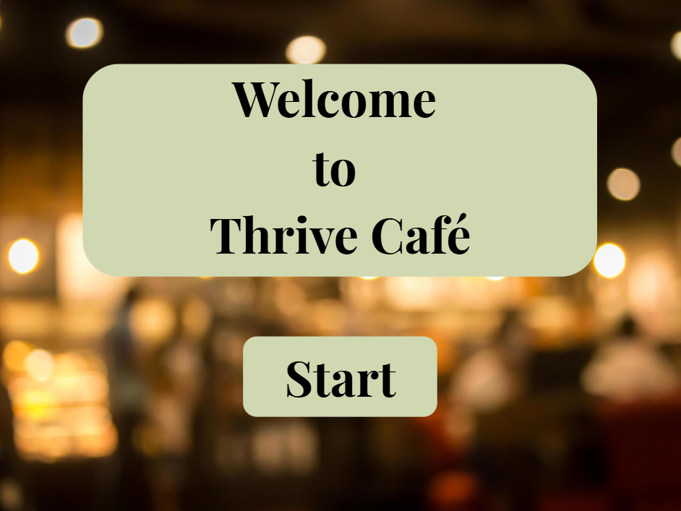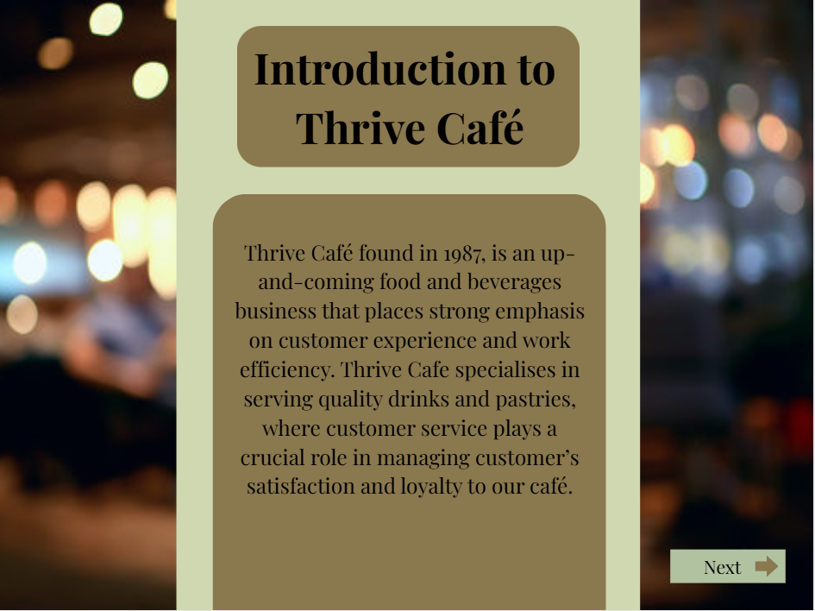

Figure 1: Main Menu Figure 2: Introduction page

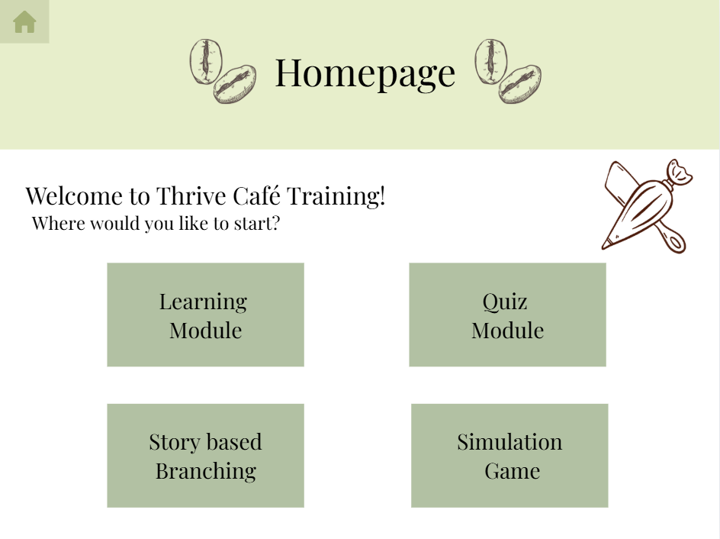

Figure 3: Homepage

1. **Simulation Game (Venise)**

Through a simulator, staff members will be able to use this game as a way of learning the basics of being a staff at Thrive Cafe. This simulator helps to create a digital experience before they work face-to-face with real customers. It is also useful as they can restart if necessary. This gives the staff members time to learn and understand their objectives, and learn how to communicate with customers better, without affecting the company or reputation of Thrive Cafe. Since staff members are not just servants, in this game, there will be three different jobs with different objectives. These jobs will provide tasks relevant to their job, where the staff will have to complete them all in time. To clarify, the job options are only for customer service. The overview of their choices is a waiter that takes orders, serves customers, cleans tables, and hands out bills for customers, a bartender that makes the drinks and gains feedback of the drinks from customers, and a cashier that focuses on transactions and interaction with customers.

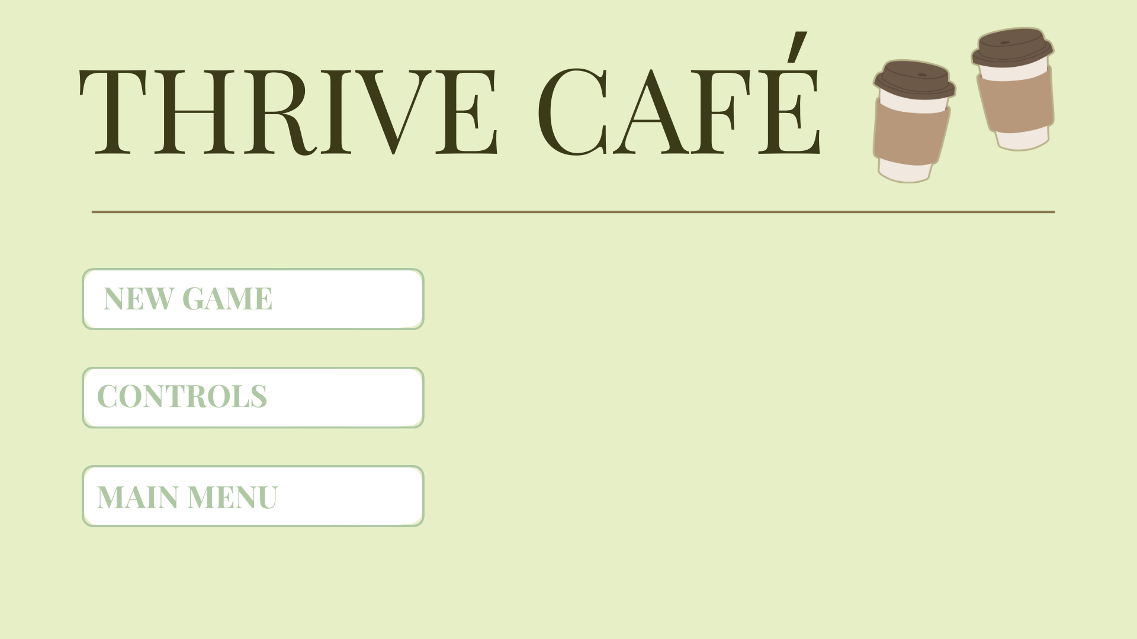 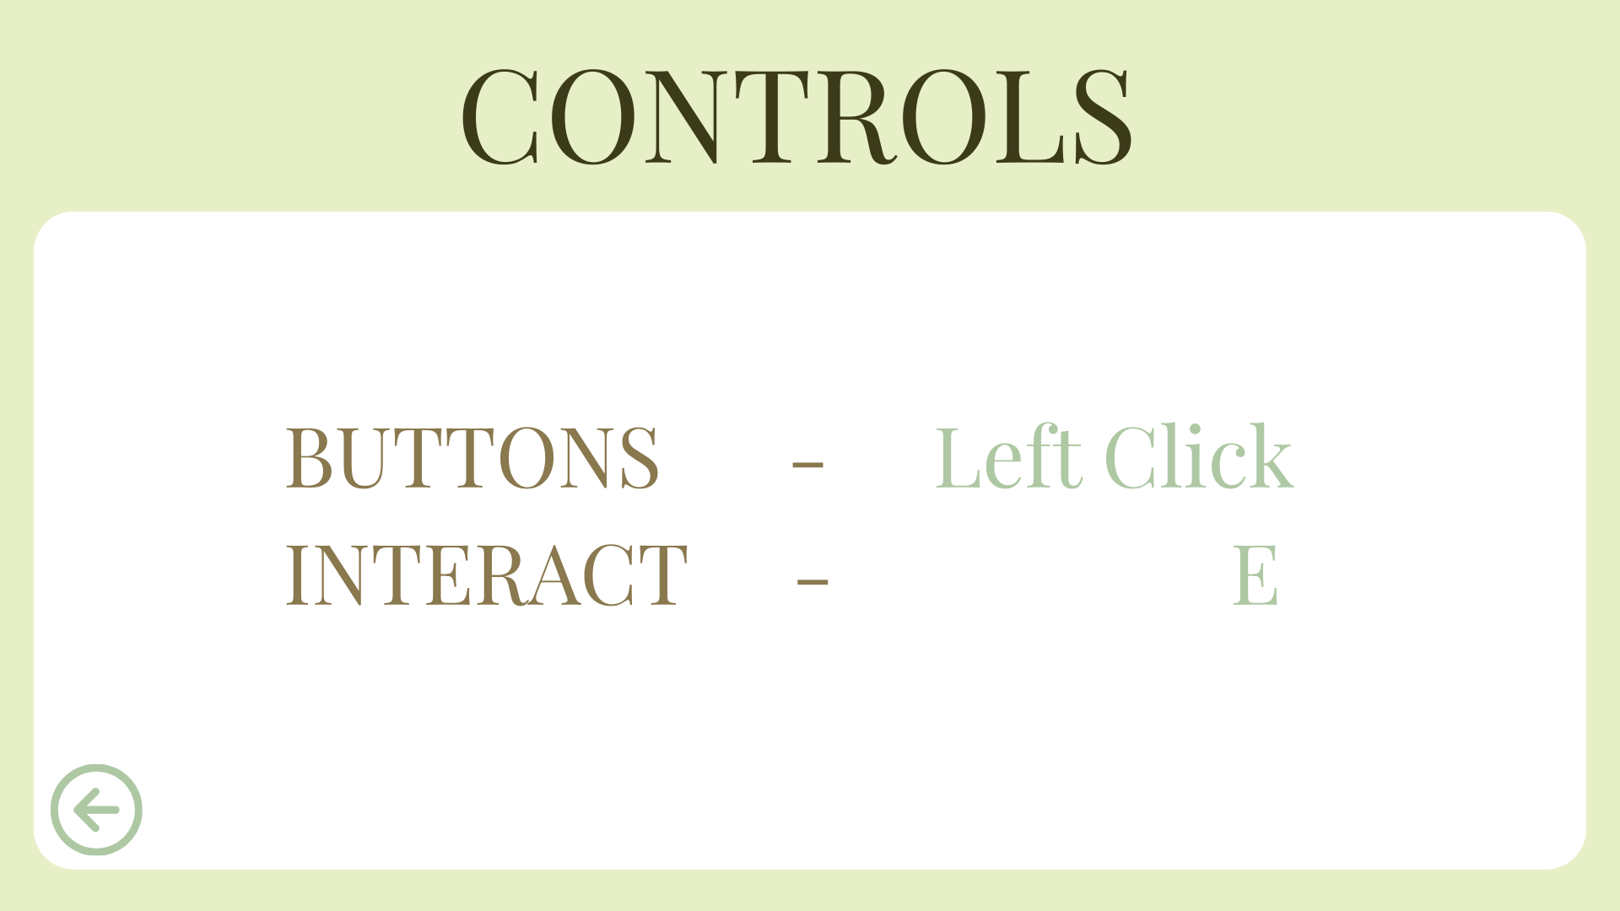

Figure 1: Game homepage Figure 2: Controls page

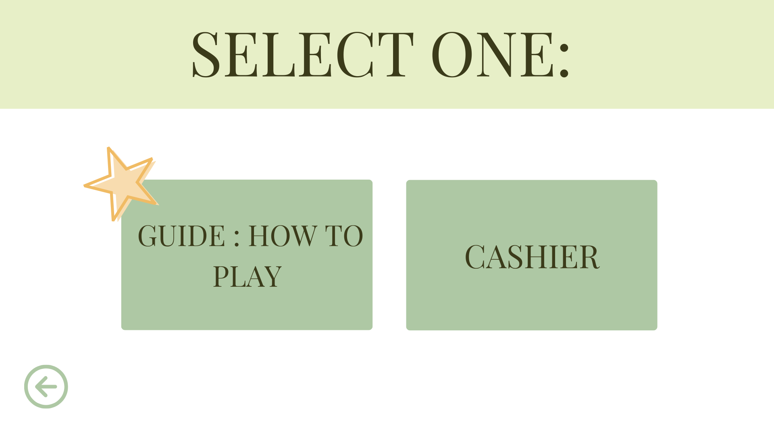 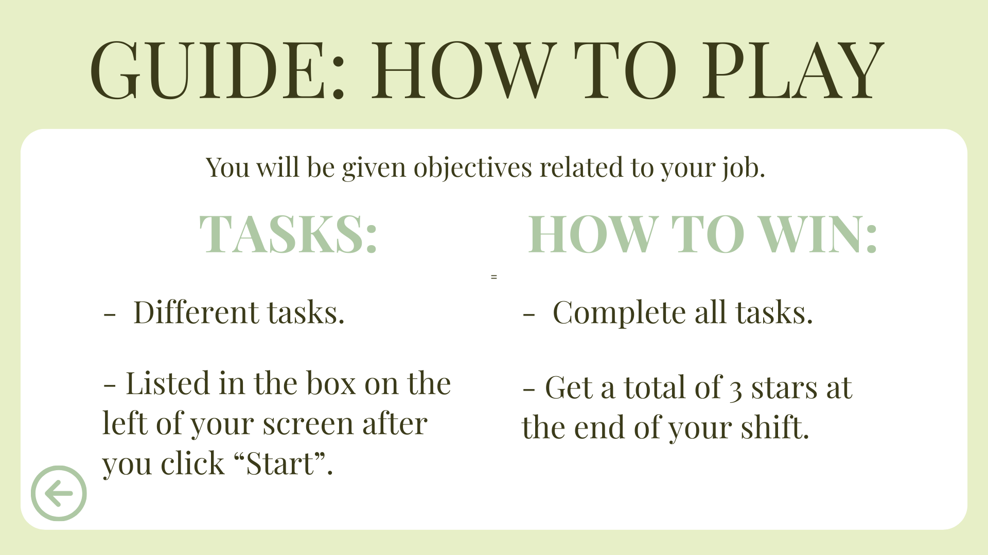

Figure 3: Main page Figure 4: Guide page

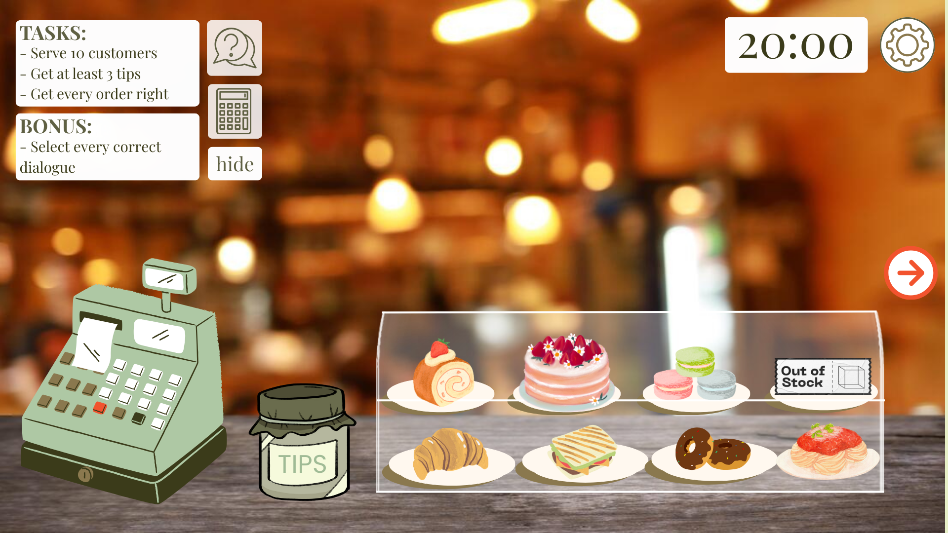 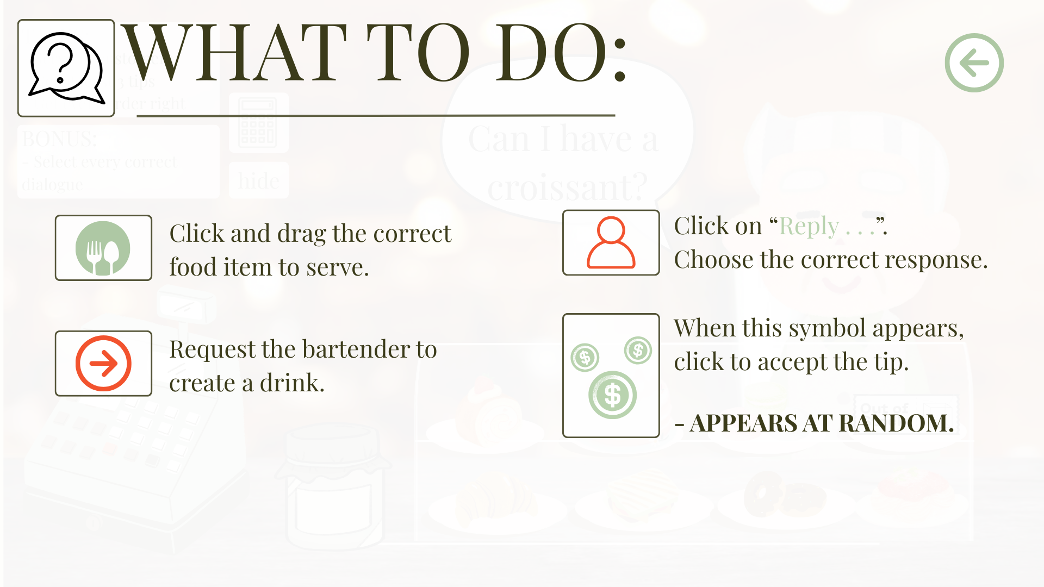

Figure 5: Cashier gamepage Figure 6: Cashier guide

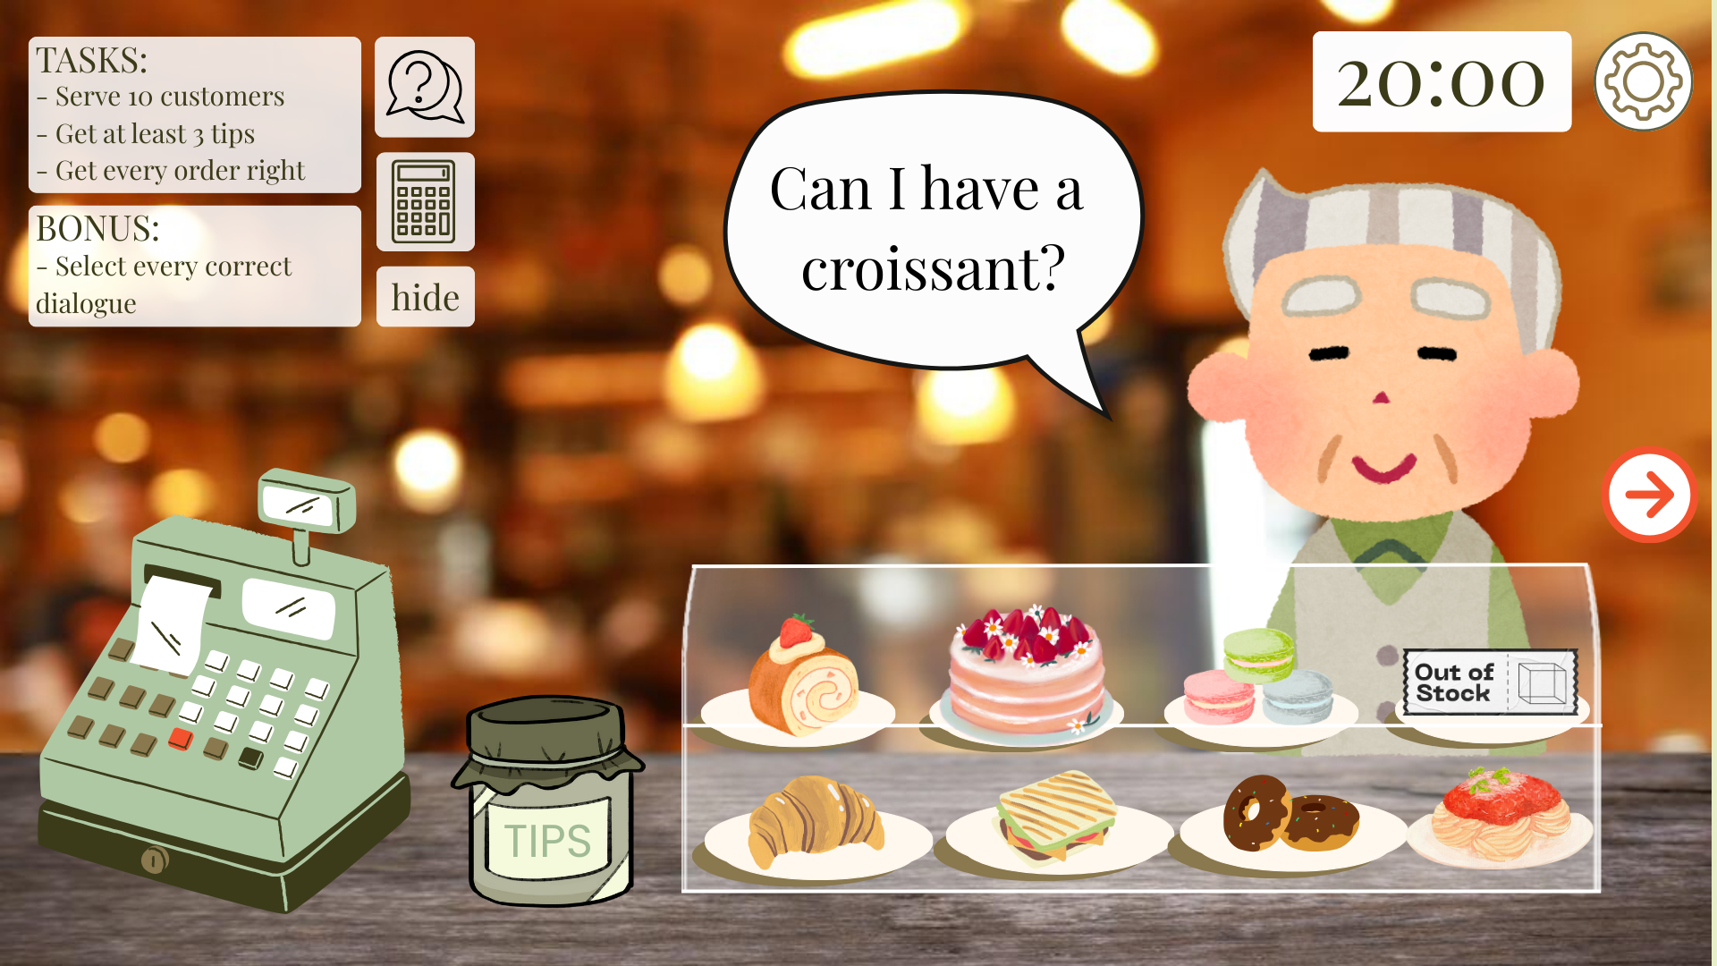 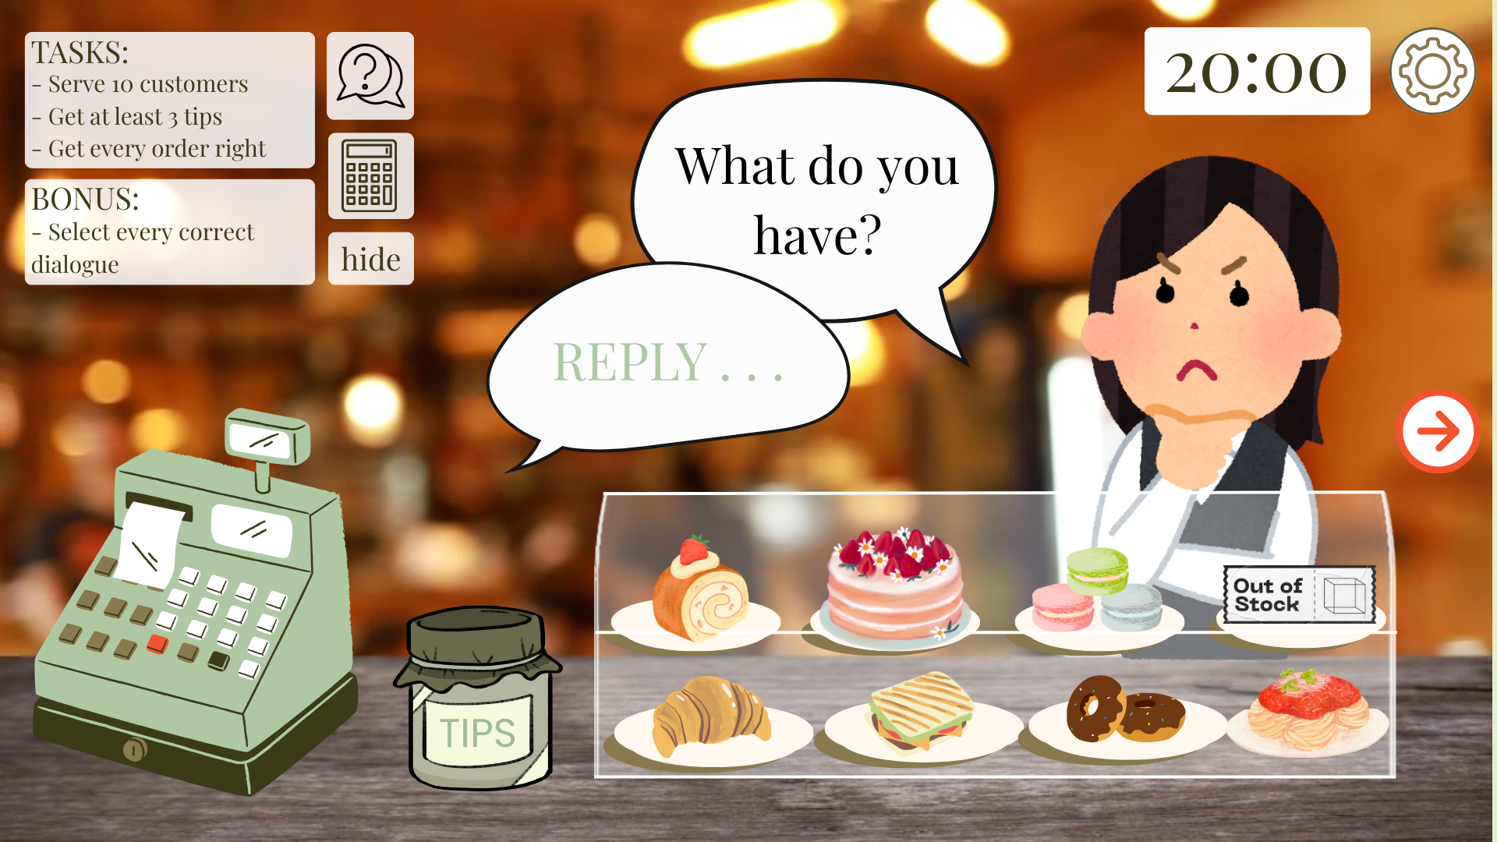

Figure 7: Task one page Figure 8: Bonus guide

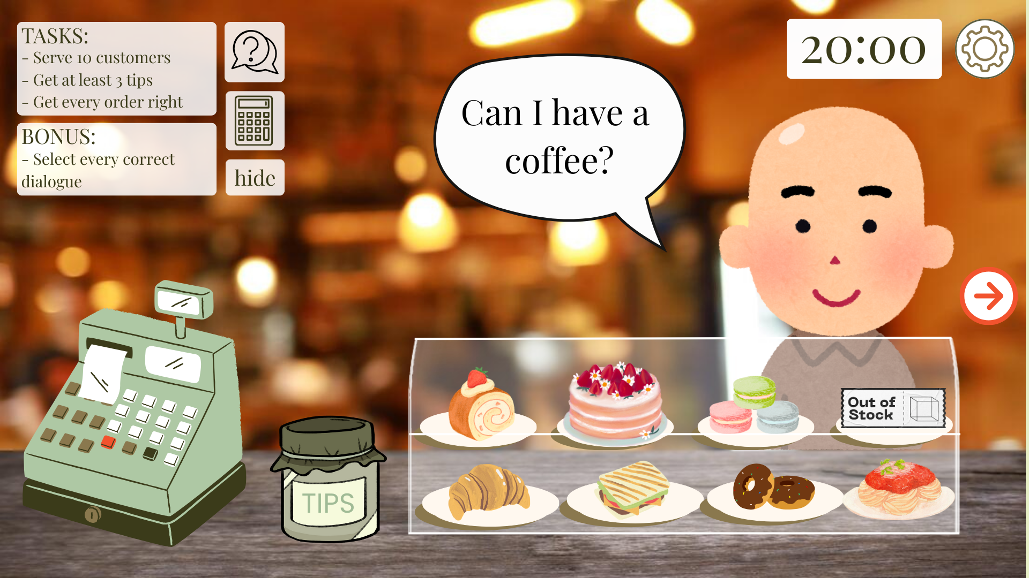 

Figure 9: Request guide Figure 10: Bartender guide

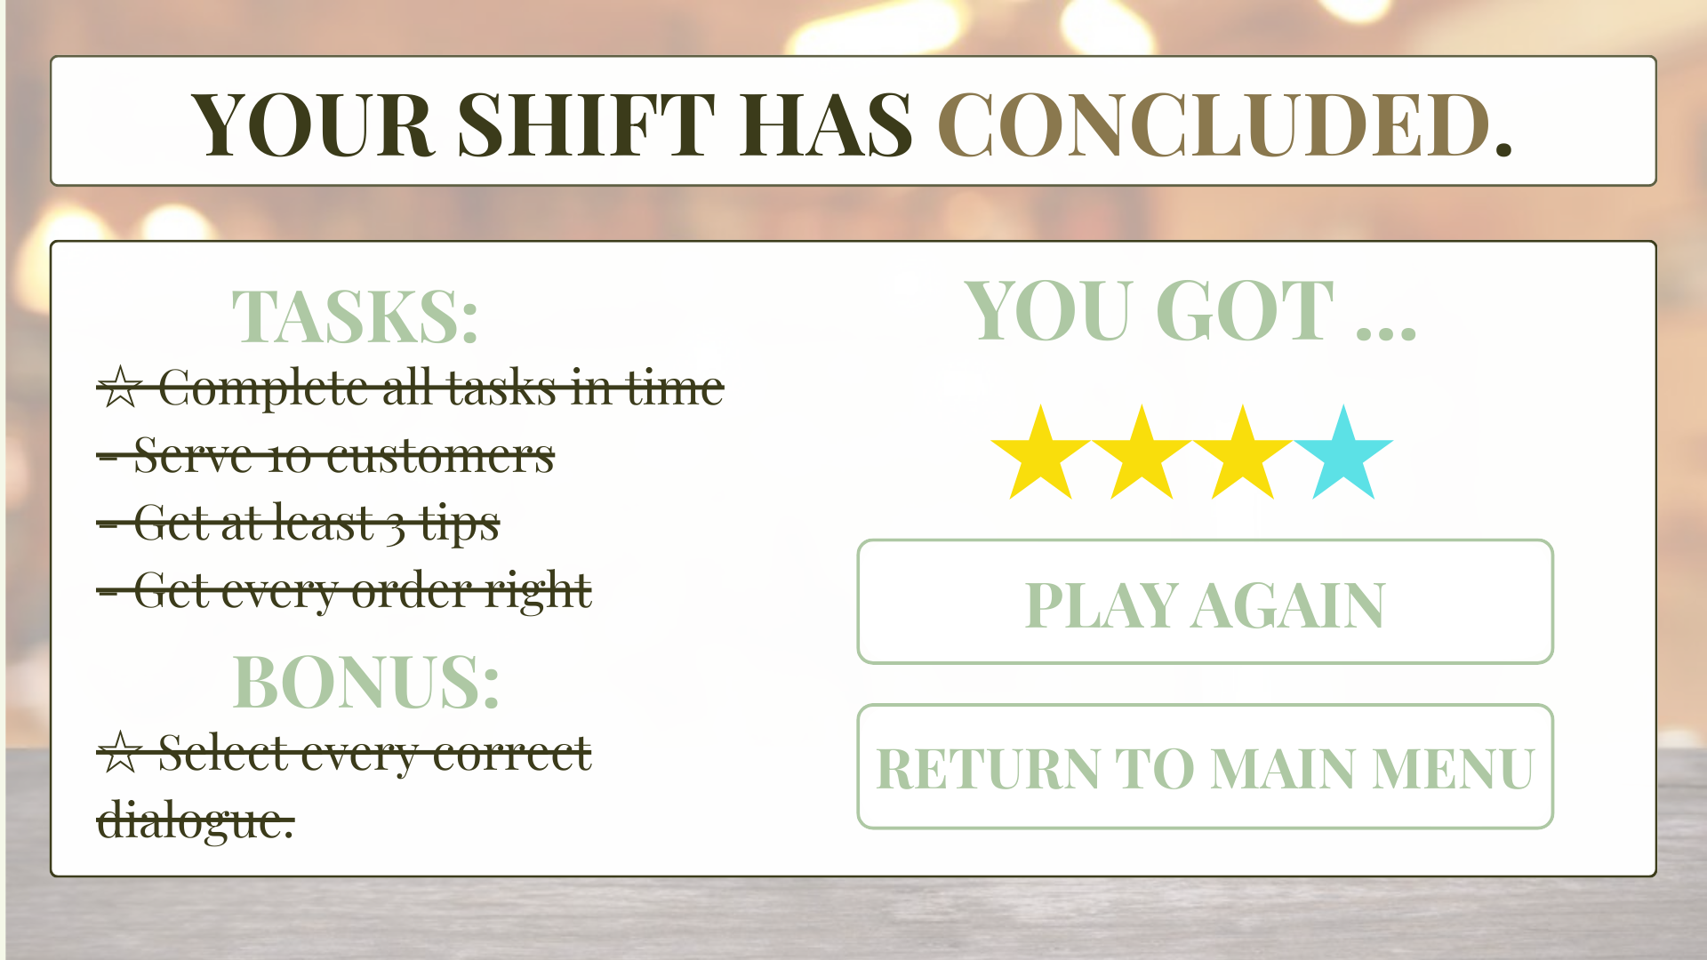

Figure 11: End of game page

1. **eLearning module (kaede)**

The main purpose of the eLearning module is for new staff to learn the basics of proper customer service through simple slides and elements interactions. Having this module ensures that every staff member will be learning the same core training, including how to greet the customer, how to take orders, how to handle requests and managing complaints. By learning at their own time before starting work at Thrive Café, staff can understand what is expected of them and help build their confidence, in a safe, non-pressuring environment.

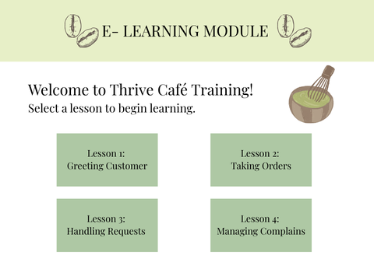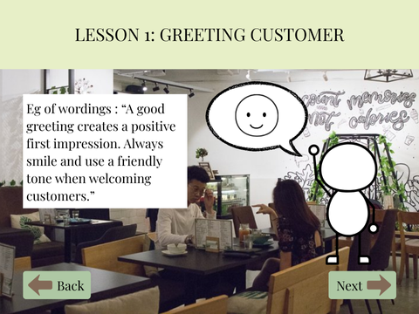

Figure 1:E-learning homepage Figure 2: E-learning lesson page

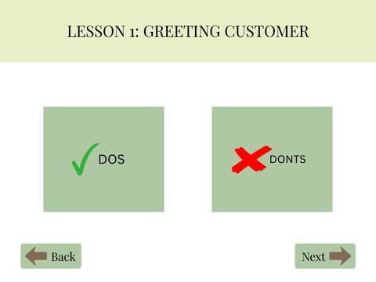 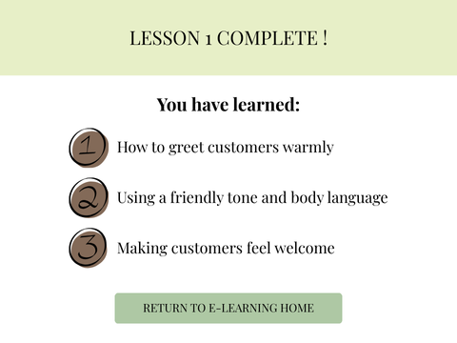

Figure 3: E-learning lesson page Figure 4: E-learning summary page

1. **Quiz Module (jinhui)**

The focus of the Quiz Module is to assess whether new staff understand the main customer service skills taught in lessons, such as e-learning and simulation games. Through concise questions and instant feedback, staff can find and improve their mistakes, making the entire learning process clearer and more interesting. Not only that, but it also helps trainers take notice of the common areas where most staff struggle, so they know which areas and who need more practice. This helps everyone to meet the required training standards and feel more confident before facing a real customer.

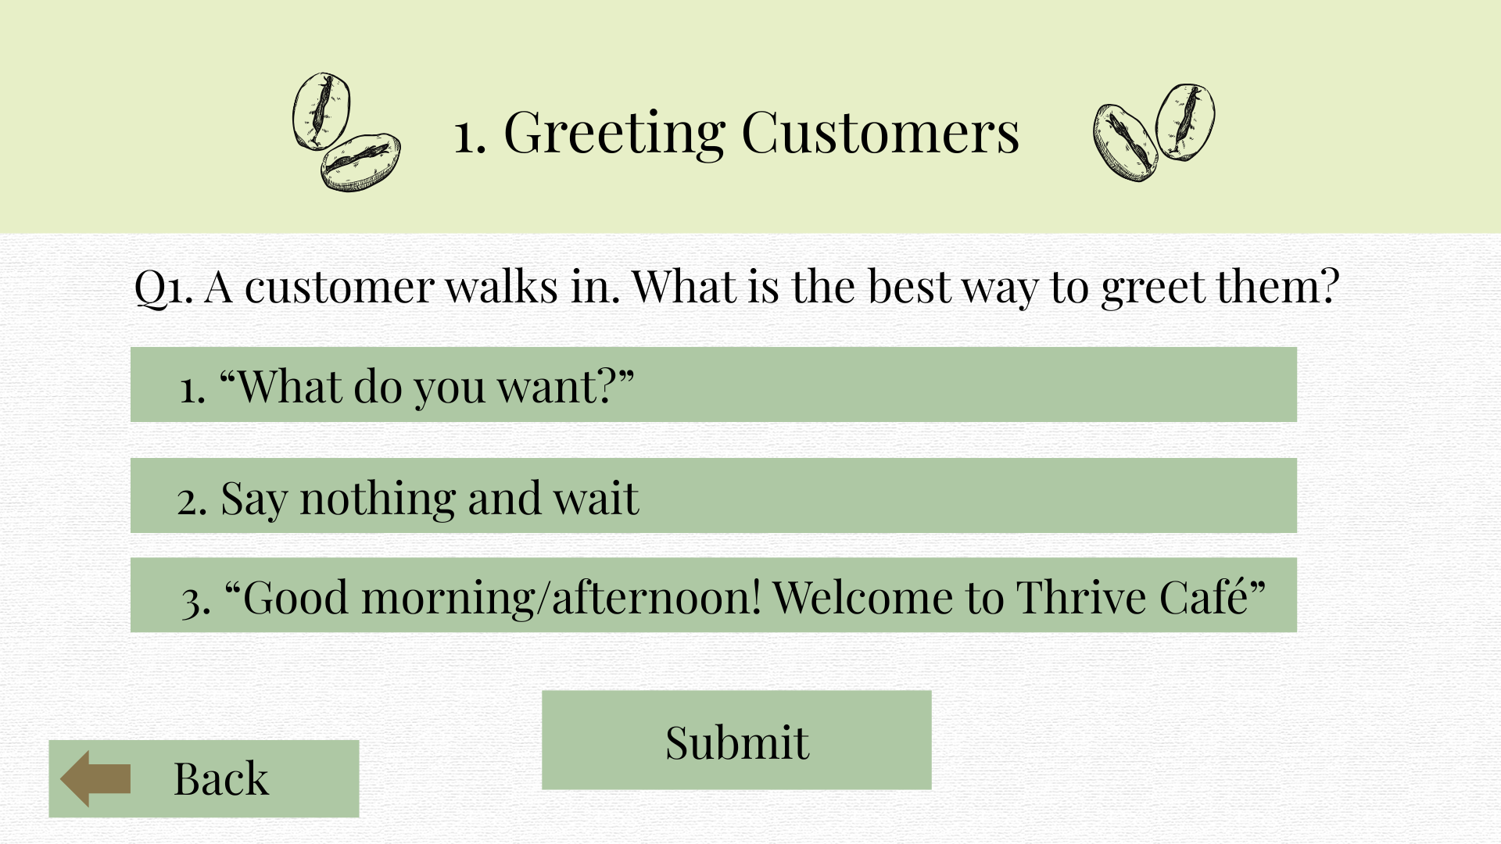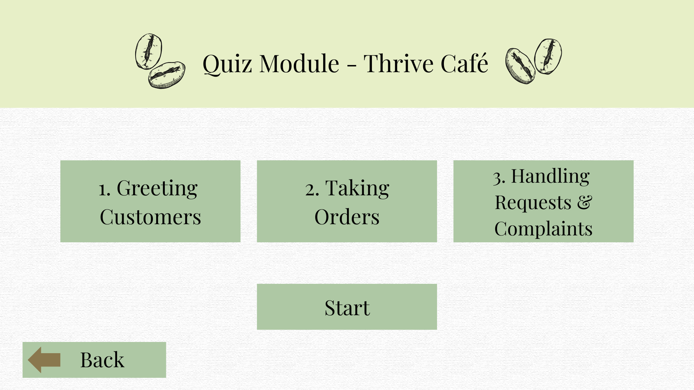

Figure 1: Quiz Homepage Figure 2: Quiz lesson page

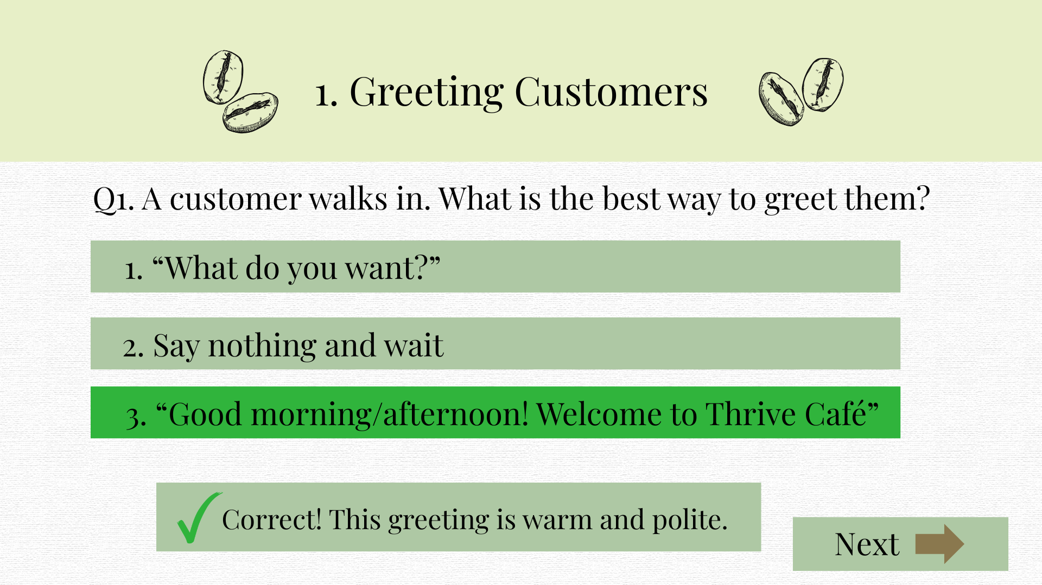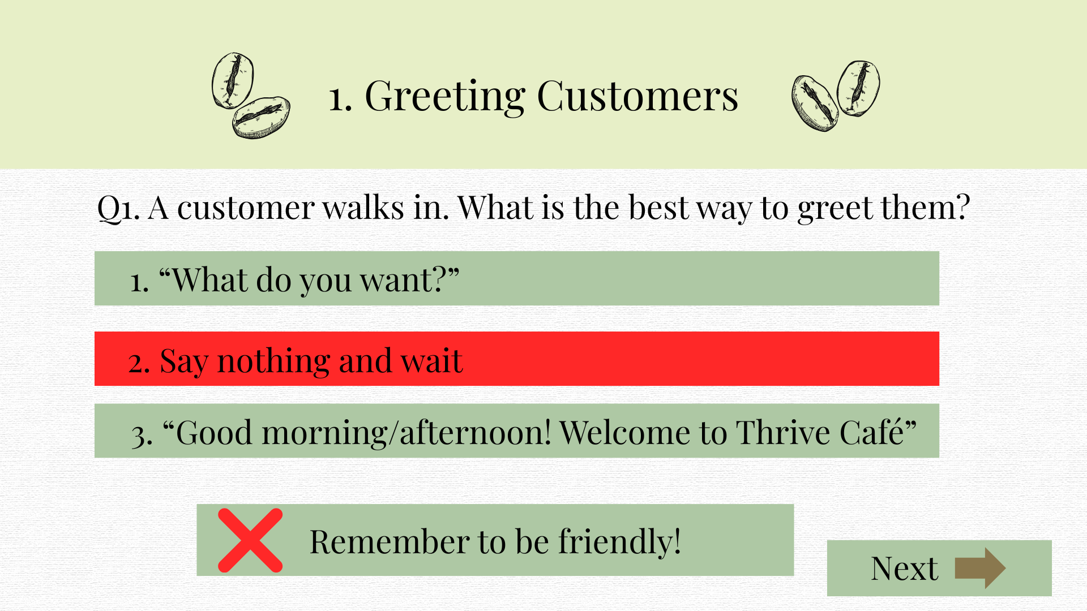

Figure 3: Quiz feedback page Figure 4: Quiz feedback page

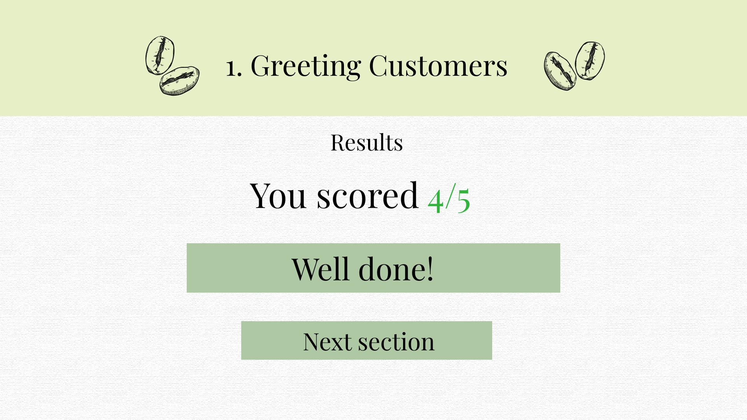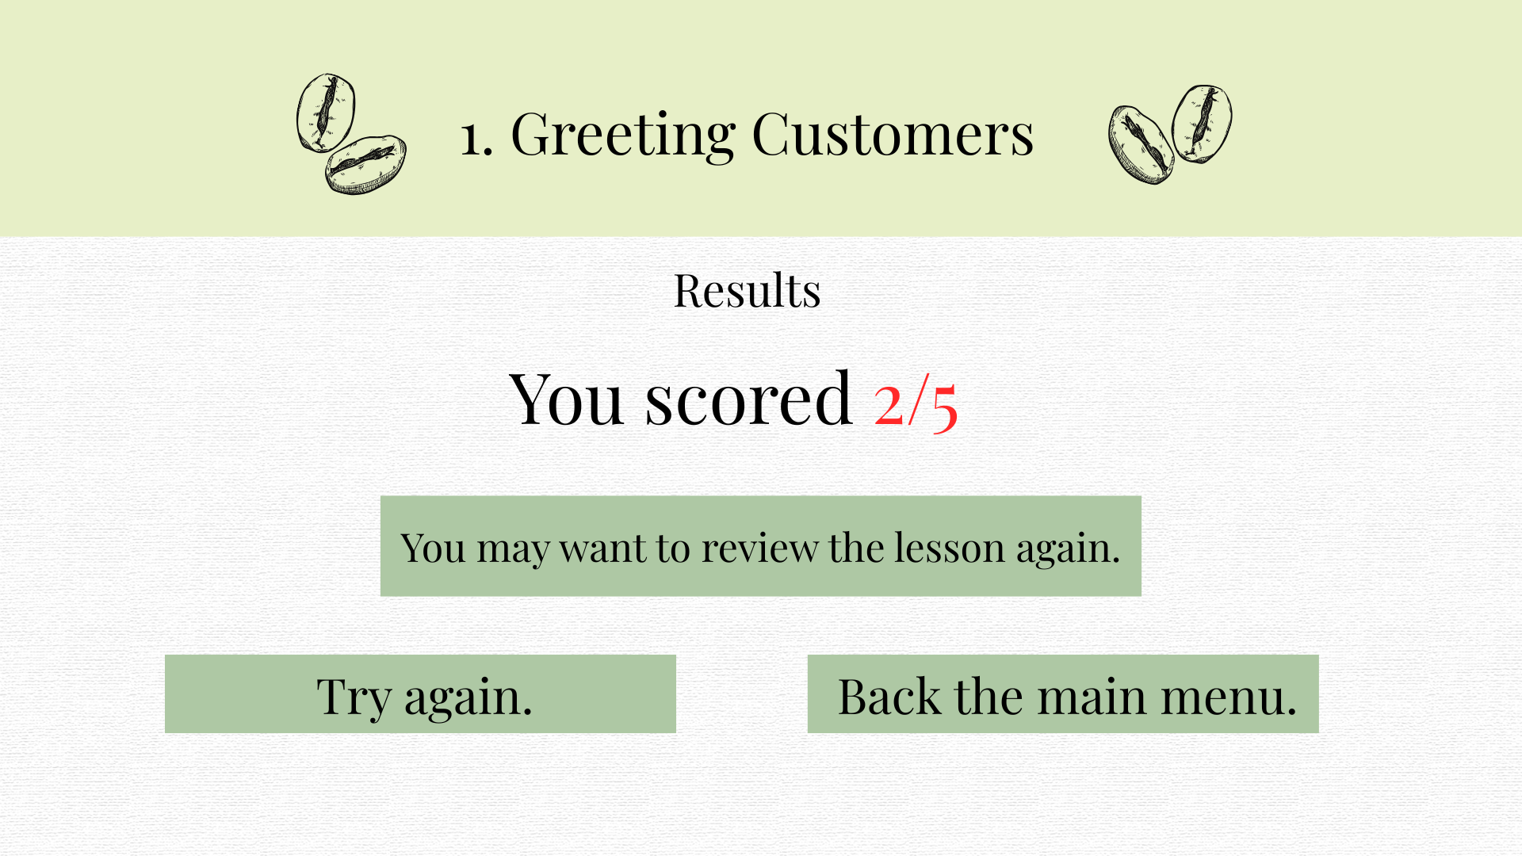

Figure 4: Quiz scoring page Figure 5: Quiz scoring page

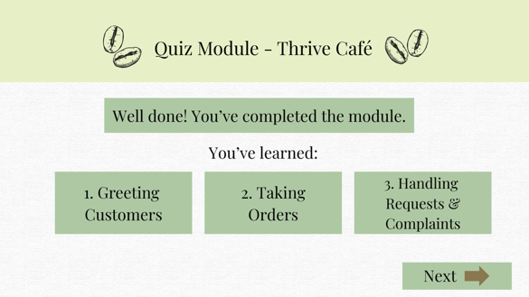

Figure 7: Quiz summary page

1. **Story-based Branching (Deva)**

Food & Beverage businesses like Thrive Cafe need staff to be able to make quick and right decisions in different scenarios while interacting with customers.

Story-Based Branching is the method that would educate employees to prepare themselves.

Trainee staff get a chance to explore different stories based on real scenarios that an employee might encounter during their duty.

This helps the trainees to experience the consequences of the option they chose and to build problem-solving skills overall.

This also helps staff to practice without any judgement on handling complaints and boosting their confidence.

This supports self-paced learning, as many trainees get to repeat the scenarios as much as possible, unlike face-to-face training, where they must try their best to catch up.

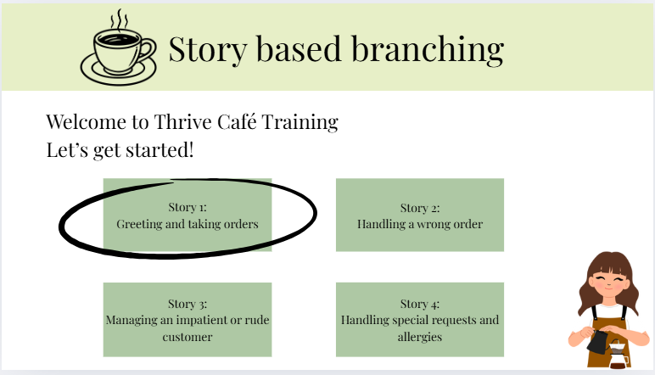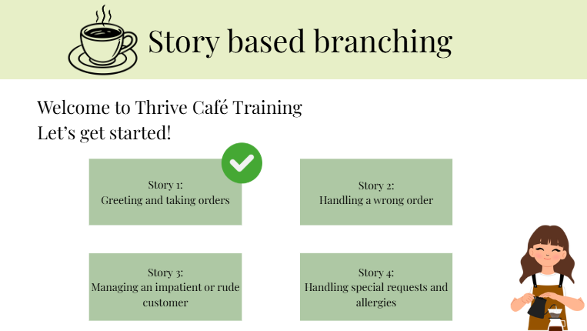

*Figure 1: Story based branching Homepage*  *Figure 2: Story scenario*

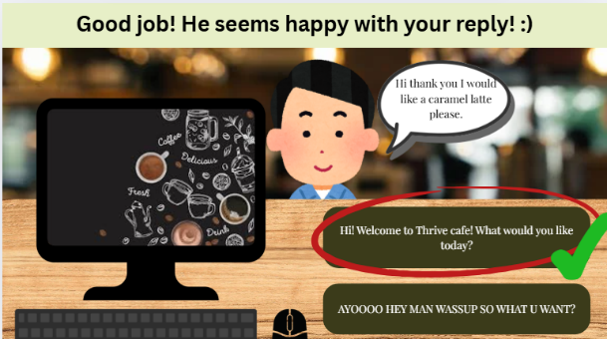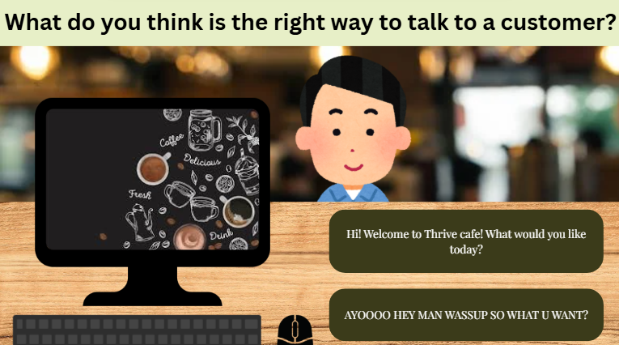

*Figure 3: Example Scenario of Story Based Branching* *Figure 4: Correct answer picked in scenario*

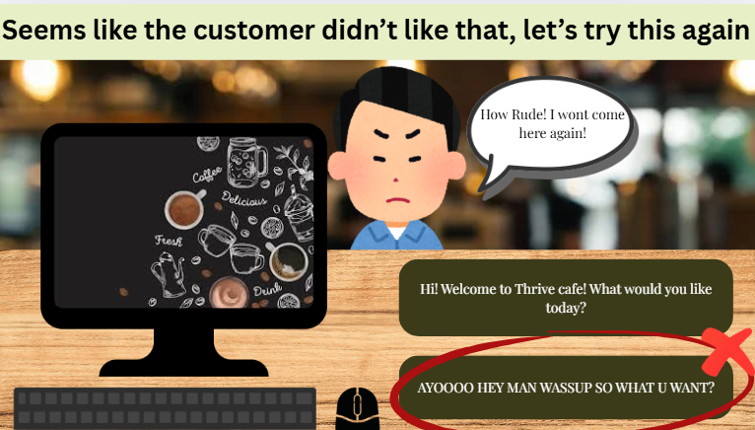



*Figure 5: Wrong answer picked in scenario* *Figure 6: Completion page*

**Project Schedule**



**References**

1. Pelkey, M. (2025, June 16). What is Operations? And Why Does My Business Need It? OnDeck. <https://www.ondeck.com/resources/what-is-operations>
2. What is business strategy & why is it important? (2022b, October 20). Business Insights Blog. <https://online.hbs.edu/blog/post/what-is-business-strategy>
3. Lparsons. (2025, October 21). How to Build — and Improve — Company Culture - Professional & Executive Development | Harvard DCE. Professional & Executive Development | Harvard DCE. [https://professional.dce.harvard.edu/blog/how-to-build-and-](https://professional.dce.harvard.edu/blog/how-to-build-and-improve-company-culture/#How-to-Repair-Company-Culture) improve-company-culture/#How-to-Repair-Company-Culture
4. Bennett, A. (2024, February 23). Maximizing Employee Potential: The Business case for Workplace Belonging. The Diversity Movement. <https://thediversitymovement.com/what-is-workplace-belonging-why-is-it-important/#:~:text=Belonging%20is%20Important%20to%20Business,willingness%20to%20recommend%20one's%20job>